# Django Application

Django applicaton can be improved and initiated by installing piip firslty. Then django frameowrk can be downloaded using pip to create the project and run the project locally in order to create hello world appl.



|  |
| --- |
| In this screen, the production of a virtual environment is shown. It is expected to make a Django application utilizing the python bundle. Production of virtual climate incorporates .venv bundle which used to use the pip. To make helloworld and to enact the contents above orders are given |

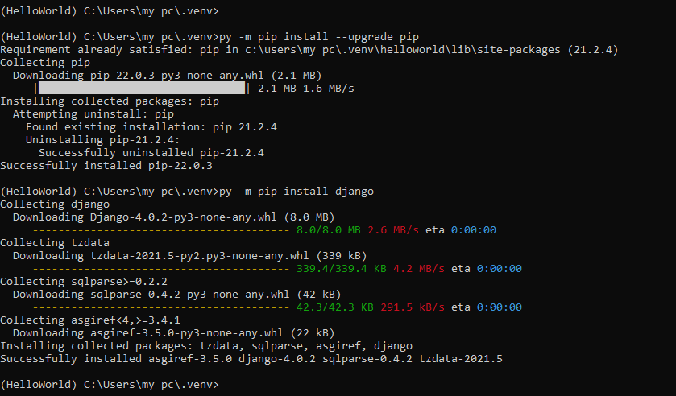

|  |
| --- |
| Install pip to utilize the Django framework. To initiate Django framework use following command “py –m pip install django” (Djangoproject.com, 2022). |



|  |
| --- |
| This order is for the most part used to run start the Django project. However, the watchword 'django_project' as it doesn't uphold the made document name. Previously, arriving at this interaction, it is essential to arrange the data set and documents, for example, - init-.py, urls.py, settings.py. These documents are required to have been followed first to get the suitable URL. |



|  |
| --- |
| Along with the final configuration, start the helloworld app. (Liquidweb.com, 2020). |

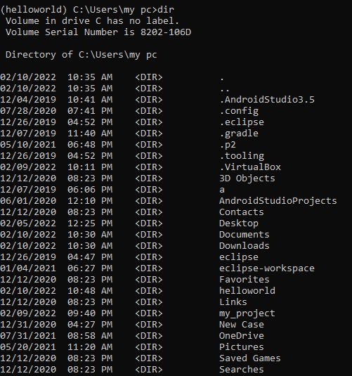

|  |
| --- |
| To start running of directory of helloworld, it is important to recover the path to know about the presence of particular directory. |



|  |
| --- |
| Run the server with the HTML script to print the helloworld. It will be happening on the particular path with the corresponding server and make utilize manage.py file. |



|  |
| --- |
| After making JSON object, run html script within the correct directory. Then it producing the answer in web browser. |

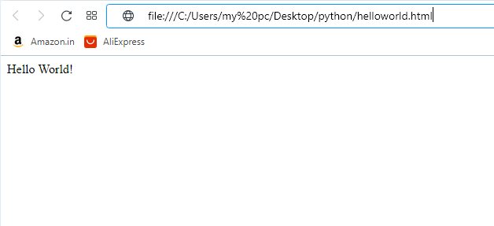

|  |
| --- |
| This result happening on the web browser by running HTML code. (Oracle.com, 2022). |

# References

Djangoproject.com. (2022). *How to install Django on Windows*. Retrieved from Djangoproject.com: https://docs.djangoproject.com/en/4.0/howto/windows/

Liquidweb.com. (2020, September 18). *How To Set Up A Python Virtual Environment On Windows 10*. Retrieved from Liquidweb.com: https://www.liquidweb.com/kb/how-to-setup-a-python-virtual-environment-on-windows-10/

Oracle.com. (2022). *Class JSONObject*. Retrieved from Oracle.com: https://docs.oracle.com/en/middleware/maf/2.5.1/reference-java-api/oracle/adfmf/json/JSONObject.html